Podiatry fact sheet – Dry Skin and Fissures

What is dry skin?

Normal skin is made up of 10% water. With dry skin, this is much less and is known as anhidrosis. This is common and can happen to anyone but more so with ageing, psoriasis, eczema, some medical conditions or can be because of a medication you may be taking.

Symptoms include roughness of the skin, itching, tightening of the skin, and cracking particularly around the heel of the feet.

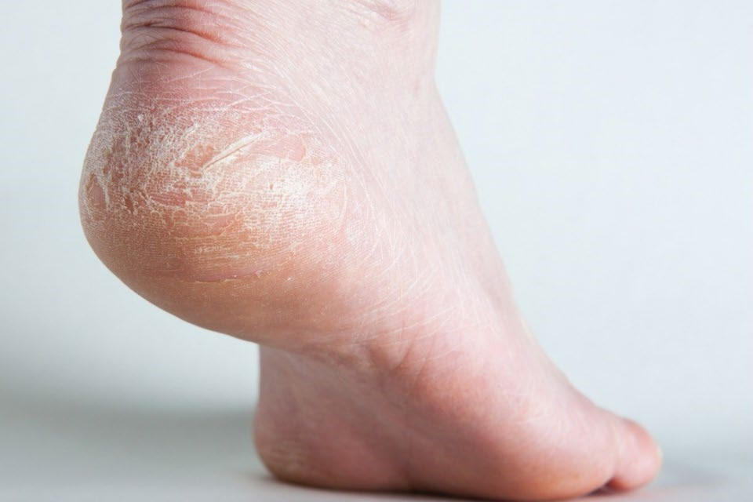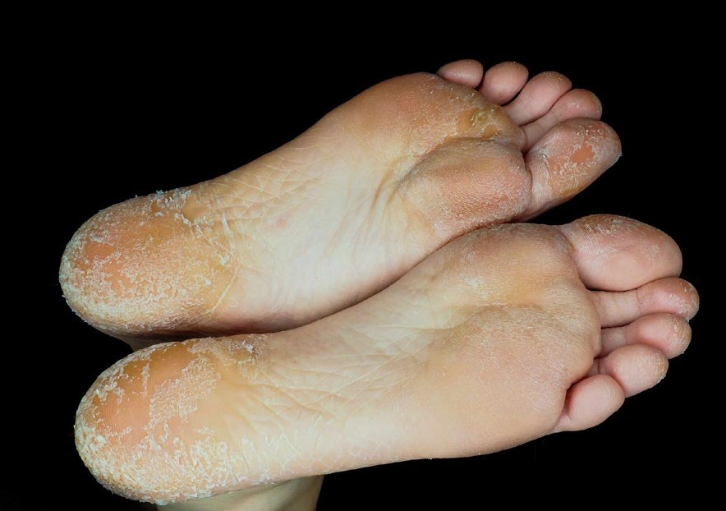

What can you do to help?

- Using a simple moisturiser on your feet every day (ideally morning and night) can help the signs of dryness; they can increase the water content of the skin or help retain water in the skin. Emulsifying ointment or Aqueous cream is often sufficient – it needn’t be a specific foot cream.

- Moisturiser is most easily absorbed about 10 minutes after you have had a bath or shower. Apply it all over the foot – but not between the toes. Rub in well and wipe of any excess.

- Other therapies include soaking the feet in an oily water foot bath.

- For an intensive overnight treatment, thickly apply petroleum jelly, wrap cling film over the feet loosely (so the petroleum jelly can only soak in) and go to bed with a pair of cotton socks.

- Heel balms specifically for dry cracked heels may be purchased from the Chemist.

- A pumice stone can help to remove dead dry skin from your feet. Dip the pumice stone in warm water, gently move the stone in circular motion around the feet. Apply moisturiser afterwards. NB: If you have an injured or sore area to the foot do not use a pumice stone on the feet.

What are Skin Fissures?

Fissures or splits occur when there is a lack of elasticity in the skin, usually when the skin is too dry or too moist.

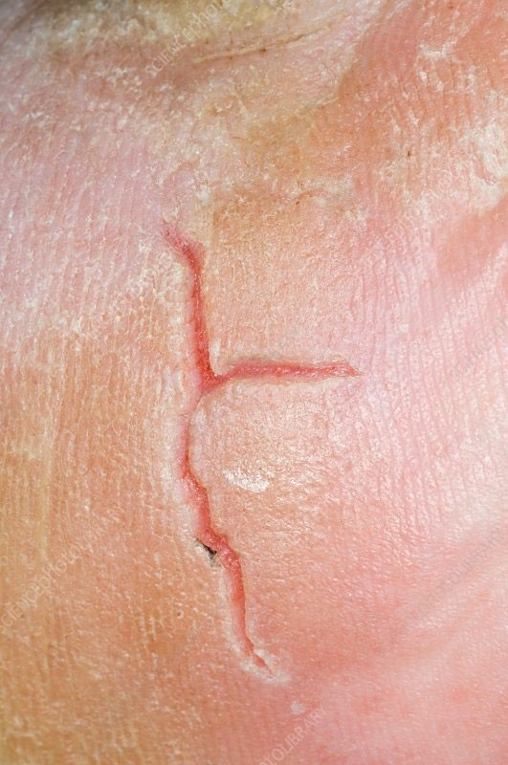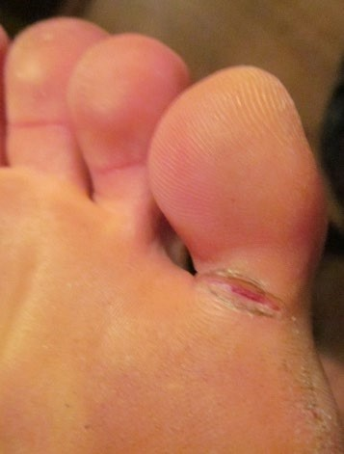

When fissures are caused because you have sweaty feet, then the treatment is to limit the amount of moisture.

This can be done by swabbing the whole foot with Surgical Spirit daily. Do not apply to broken skin. If you are pregnant or breastfeeding, ask your GP if it is safe for you to use.

If the feet are excessively sweaty your GP can prescribe topical agents i.e., Anhydrol Forte to control the moisture.

When fissures are due to very dry skin, then use a foot file / pumice regularly to limit the build-up of hard skin. Using a moisturizing cream daily will also help to soften the skin, as well as improve the elasticity.

What are Heel Fissures?

Heel fissures due to very dry skin are more common in the summer. This is due to the hotter weather and wearing sandals with open backs. When the heel sits on the back of the sandal it can be squashed and pinched over the outer edge of the sole of the shoe. To avoid this, ensure that the heel seat of your sandal is wide enough to accommodate your heel.

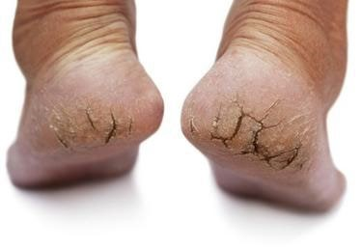
If the skin is split, then cover the area with a clean / sterile dressing such as Melolin or gauze until it has healed. If the fissure does not heal after a couple of days, or your feet are at high risk of developing foot ulcers, contact your GP or local foot protection team for advice.

