Glossary of Terms

Discharge to Assess (D2A)
An approach to intermediate care in which people are discharged from hospital as soon as medically ready so that long-term assessment can take place at or close to home instead of waiting to have that assessment while still in hospital.
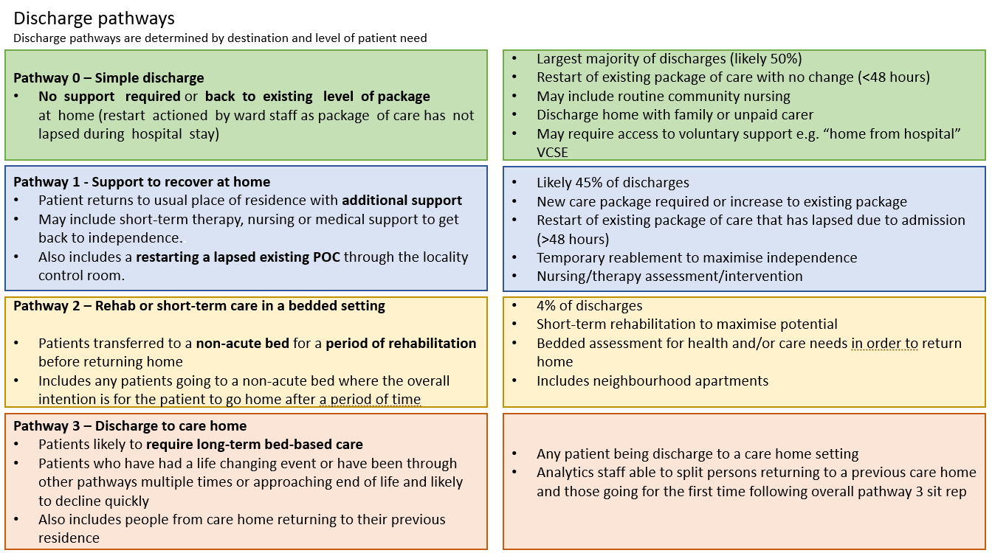

Expected Discharge Date (EDD)
This is the date the patient leaves the hospital this should be moved as necessary to align with the clinical and discharge progress information. This should be recorded on HIVE
Criteria to Reside
Every person on every general ward should be reviewed on a twice-daily ward round to determine the following and recorded on HIVE. If the answer to each question is ‘no’, active consideration for discharge to a less acute setting must be made:
- requiring ITU or HDU care?
- requiring oxygen therapy/NIV?
- requiring intravenous fluids?
- NEWS2 greater than 3? (Clinical judgement required in persons with AF and/or chronic respiratory disease)
- diminished level of consciousness where recovery realistic?
- acute functional impairment in excess of home/community care provision?
- last hours of life?
- requiring intravenous medication > b.d. (including analgesia)?
- undergone lower limb surgery within 48 hours?
- undergone thorax-abdominal or pelvic surgery with 72 hours?
- within 24 hours of an invasive procedure? (With attendant risk of acute life- threatening deterioration)
Clinical exceptions will occur but must be warranted and justified. Recording the rationale will assist meaningful, time efficient review.
Strengths based approach.
A strengths-based approach focuses on an individuals’ strengths (including personal strengths and social and community networks) and not on their deficits. Strengths-based practice is holistic and multidisciplinary and works with the individual to promote their wellbeing.
It is an approach to working with a person that focuses on what they or their support network can do rather than approaching it from the perspective of what they cannot do.

