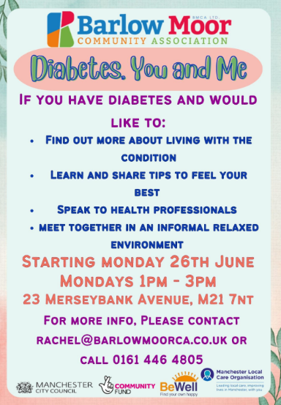
Diabetes Project: Started June 2023
Current investment £7k – staff and room hire budget for speakers and specialist practitioners for 1year-18 months Chorlton Park
Project management-HDC:
Delivery- Be Well, BMCA and PCN partnership
Aim
- To support effective management of diabetes
- Clear targeted education sessions looking at nutrition, healthy weight, physical exercises and well being
- Space for patients to bring and resolve questions, learn and support each other and build relationships.
- Ongoing resource close to home where GPs and nurses can refer patients to learn about and get support around diabetes
- Focus on different cultural needs and identities and how this can impact on managing diabetes.
- Ambition to support Practices when they deliver diabetic reviews by group members to be present in waiting rooms and have discussions with patients attending for review to offer support
- Reduce unplanned GP appointments for diabetes amongst group members
- Improve annual review attendance and QOF target achievement

Proposal = £5-7k for group in Burnage staffing, room hire and sessional workers
Time line- Start Autumn 2023

Led by worker form Project CHA supported by PCN, HDC and potentially Diabetes UK

Based at location in Burnage TBC

Similar aims but more accessible to Burnage patients and specialised South Asian community focus
Partnership meeting 190 invest:
- Carers welcome everyone
- Link with levenshulme HDC?
- Need for people outside working hours

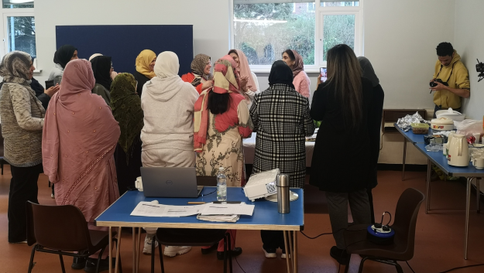
Project CHA Fridays term time at Burnage Community Centre
Successful community engagement and community development with South Asian women
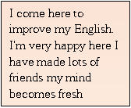
Aim=Increase knowledge of participants, and form ongoing supportive group to coproduce direction of group and subject matter, become involved in partnership and potentially other groups and potentially support campaigns and health work over 18 month period
Project has been ongoing for nearly 2 years and successfully delivers peer support development to group of around 20 women each week.
Initial investment of 15K has paid for room hire at Burnage community centre, community development sessional fees, events and a trip and cost of living winter warmer bags
Project Proposal for 2023-24 Investment £4-7k
Investment for development of Community health volunteer roles through more formal training and focus om individual monitoring and evaluation of outputs and impact of sharing health messaging, redesign of culturally appropriate materials
Continued investment to fund community development worker, room hire and training. Ambition for group to become self-sustaining
Law Project- Wider determinants of Health Start September 2022 funding due to run out in October 2023
Partnership meeting 1650 invest:
- Great project to continue investing in and engaging in with the south Asian community -benefits far reaching in terms of building trust and being able to engage in other health and wellbeing topics
- Bring in guest speakers eg wi yin,
- Could be amazing value if develops to CIC possibility of NCDO budget LMCP
Ongoing partnership with Southway, Buzz, MCC to fund access to legal advice in community Settings
November to March- project totals
In total 28 sessions at outreach venues. Seeing a total of 104 clients across 108 appointments
Advised 111 clients across the project so far, primarily benefit and income issues: 87
19 of these have been disability form filling cases – 4 of these have involved people with additional language or support needs. We are estimate 30K of benefit gains from these, we will look to provide
We have undertaken 23 Benefit cases on – e.g. mandatory reconsideration, potential appeals on casework basis that involved follow up. See case studies
6 housing cases – 1 is on-going. The housing cases are primarily are on housing priority. The on-going case is eviction.
4 debt cases – specifically bailiff and parking issues that were dealt with as one-off advice in terms of next steps.
Burnage – Westcroft
Didsbury Good Neighbours
Burnage Library
Chorlton Park BMCA/ Chorlton Park Primary school
Didsbury Mosque
Project Proposal for 2023-24 Investment £2-3k
Continued investment £2k for continues delivery in different venues, event based work and outreach and potentially reach out to home visiting model
Partnership meeting 2900 invest:
- Power of attorney/will writing help?
- Long term funding implications?
- Rights and advice for publicity
- Any plans to include warm banks- paces where people can keep warm
- Trussel trust-CAB contact

School Health Project 2022-23 £4.5k Partnership with healthy schools
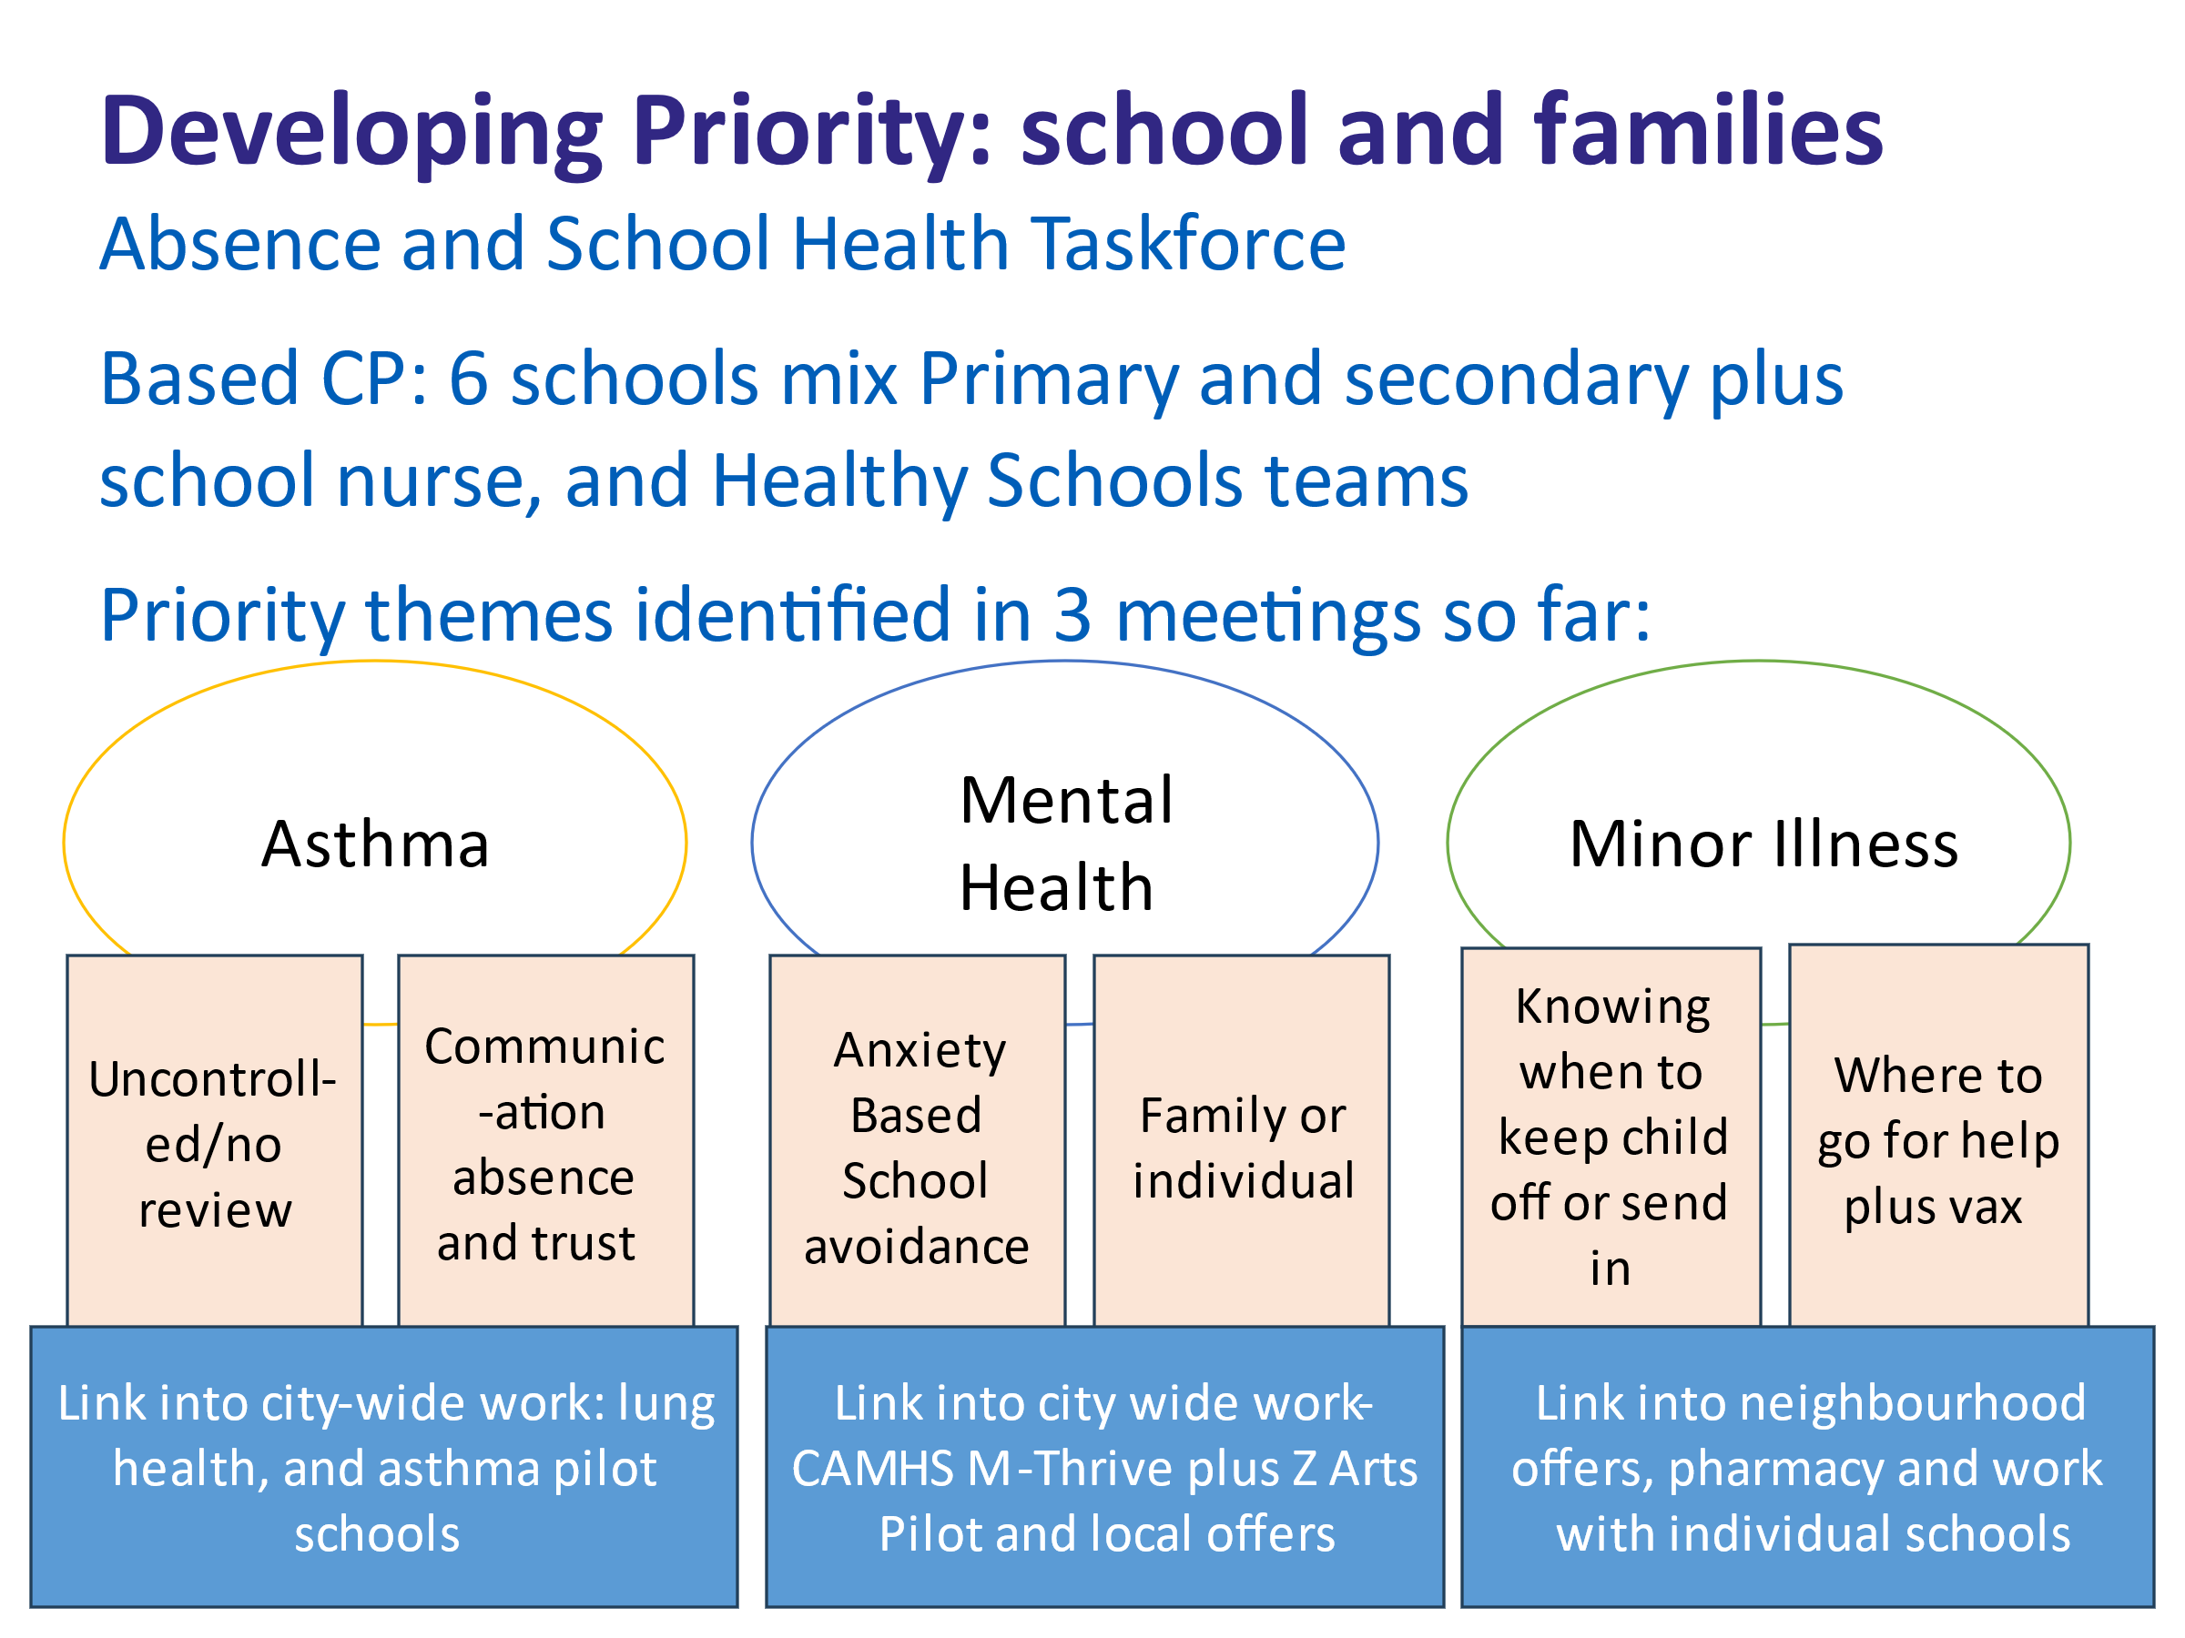
Z Arts funded project in south partnership delivering 5 way to wellbeing workshops to Y3 children at Acacia School development of workbook and video to support future project work

Project Proposal for 2023-24 Investment 4-7k to fund health and wellbeing workshops to support mental health in schools and the developing priority

Partnership meeting 1430 invest:
- Outside school hours fo parents
- Creating good engagemet and with parents is vital to getting health and wellbeing messages out that also impact on school attainment and attendance
- Workshops for SEND parents
- Parent engagement
Engagement Work
Engagement over the last year saw £3000 invested in Activity for happiness grants to 7 organisations funding wellbeing and days out for existing groups

£2,500 for project at the White House currently being piloted
Engagement funding is needed for events such as bowel screening work, hypertension and other priorities we are working to

Investment requested £2-4k to support this work
Partnership meeting 830 invest:
- Make like social prescribing – cinema trips walks etc
- Engagement vital for most projects so investing in this would benefit all projects

MLCO Neighbourhood Health and Wellbeing Fund

Annual investment of £20,000 into BCD to support project work focused on neighbourhood health and wellbeing priorities.

Process and accountability
- Development of ideas generated through partnership meetings, ongoing project and work, community engagement and health priorities
- Priorities and allocations through Partnership meetings and Integrated Neighbourhood Leadership Team
- Proposal process via HDC writing and presentation to South Manchester Provider Partnership who approve proposals
- Finance and sign off through MLCO finance and Service Level Agreements with providers
- Reporting and accountability to South Manchester Provider Partnership Group
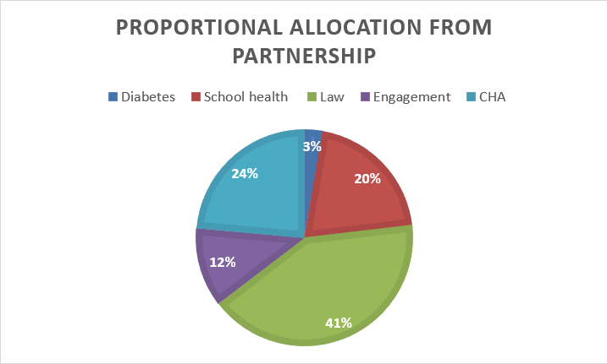

Proportional allocation from the Partnership meeting September 2023

