Manchester Healthy Weight Strategy Newsletter
  - JULY 2023
We may be just over halfway through the year but what a busy year it has been so far! In this packed edition of the newsletter, features include a family activity event organised by the Junior PARs team, a case study showcasing collaborative healthy weight work provided by the Be Well Be You groups and MCRactive, diabetes training delivered with South Asian women in Burnage and a fantastic story of a Targeted Swim Project supporting residents from Afro Caribbean communities. Finally, Team Manchester share information about the girls and young women Adventure Roadshow taking place over the summer.
Wishing everyone a safe and happy summer!
Family Activity Fun with the Junior PARS team!
During a recent school holiday, the Junior Pars (Physical Activity on Referral Service) practitioners organised a family activity day at Denmark Road. The team invited past and current families who had accessed the junior pars service, to attend the event and participate in a variety of activities including badminton, giant connect four, football, table tennis, basketball and tennis with coach Andy from ‘We Do Tennis’. Even the typical school holiday weather didn’t deter families from climbing up the outdoor climbing wall! The event was extremely well attended, and feedback highlighted how much the families had enjoyed joining in with the different activities together.
Due to the success, another family activity day is planned for the summer holidays. Well done team!

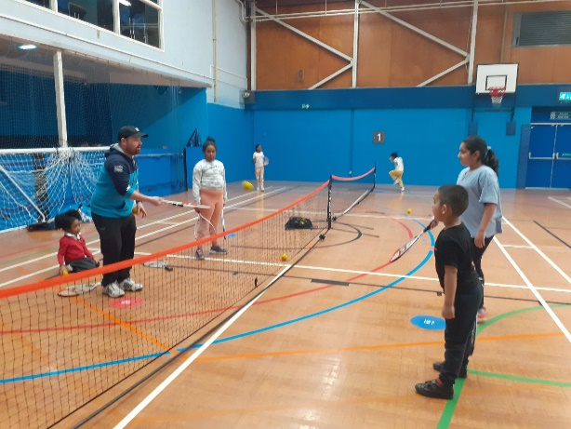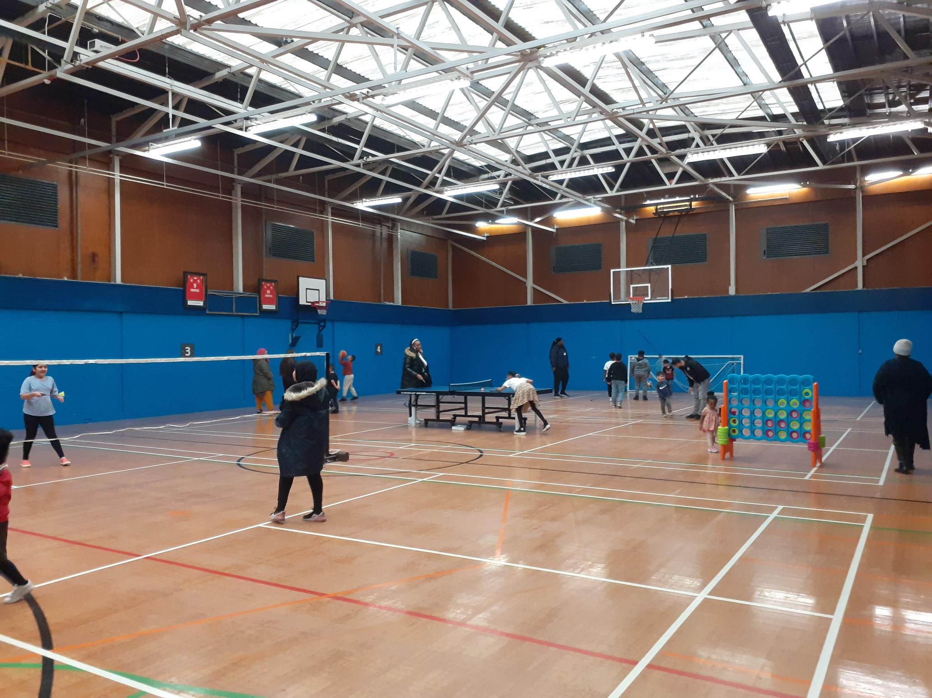

In Spotlight: ‘Be Well Be You’ Success Story

Augustin was referred by his GP for weight management support with a BMI of 33. He works full-time as a Mental Health support worker and has diabetes type II which he currently manages with diet. Augustin's feet are swollen because of his weight and diabetes. He also carries most of his weight around his stomach and his long-term goal is to reduce his waist size.

Be You Groups
Augustin signed up for the Be You group at Denmark Road. At session 2 of the group Augustin has reduced his portion sizes and had already noticed the waistband on his trousers felt loser and his weight loss had been noticed by his wife. During this session we talked about how sometimes eating habits can be related to our emotions and Augustin decided to complete the food and mood diary to see if there are any patterns, he can identify in terms of snacking for his goal which he achieved and felt that he was becoming more aware of eating habits which helped him to continue making small changes.
At each session Augustin set a goal related to what had been discussed and at the cooking session where the group made the Epic salad, the session inspired Augustin to set a goal to include 30 whole foods in his diet over the next 7 days. By session 4 Augustin had started attending PARS (Physical Activity Referral Service) and was enjoying the sessions. He felt he “was getting stronger” and was eager to see what support he could access after this course finished.
By week 5, Augustin had lost 4kg and was maintaining the changes he had made. He was feeling much better both physically and mentally and was motivated to continue improving his well-being. Through the 12 week voucher scheme, Augustin registered with Slimming World and it was agreed with MCR active that Augustin would be able to access both PARS and Pathway sessions for weight management to help him build on the progress he had made, and enable him to join other Be You members at the exercise classes. At the Walk and Talk session at Whitworth Park and Art Gallery, Augustin used the outdoor gym equipment which he plans to go back to use as he lives close by. During this session, he also spent time at the Slow Down, You're Doing Fine exhibition at the Whitworth Art Gallery which encouraged meditating on the pieces of art and felt the whole session had been very relaxing and enjoyable.

Looking forward
So far, Augustin had lost 6kg in total and he will be attending his first Slimming World meeting in June. Augustin has 2 Be You sessions left to attend but the changes he had been able to make in such a short time have been amazing and he feels very motivated to continue his weight management journey with Slimming World and MCRactive once the group ends.

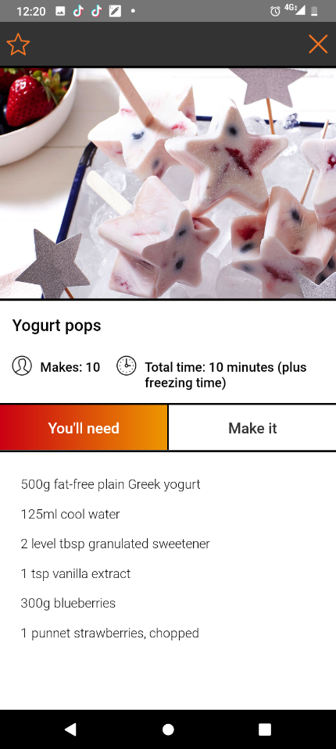
Did you know…?
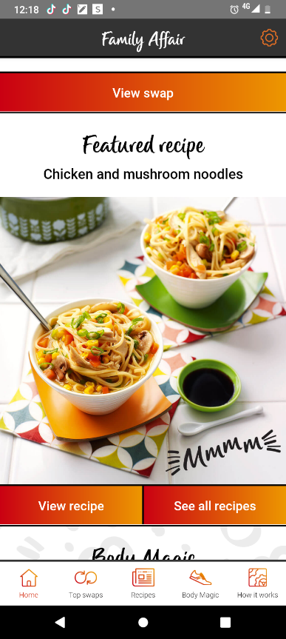
The body mass index (BMI) for people to access the adult tier 2 Slimming World voucher scheme has been reduced to a BMI of 25. Families of Slimming World members can also access a wealth of information on the ‘Family Affair’ app, including easy healthy recipes such as yoghurt pops and chicken & mushroom noodles, helping to make it easier for families to make positive lifestyle changes.
Slimming World research has found that 77% of members say that within just three months of joining group, their children were eating more healthily, and 41% of members who’ve increased activity through the Body Magic programme have encouraged their family to be more active too.
The referral scheme is open to people who are a Manchester resident or have a Manchester GP, 16 years and over and with a BMI over 25.
Be Well manage the scheme and can be contacted on 0161 470 7120 or www.thebiglifegroup.com/free-slimming-world-vouchers

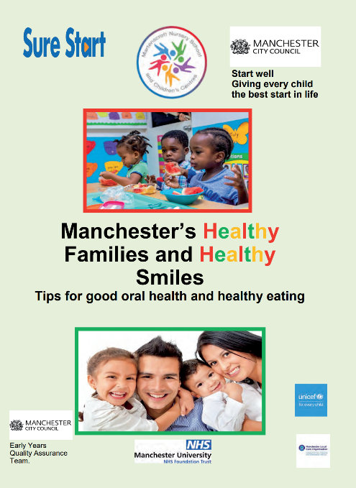
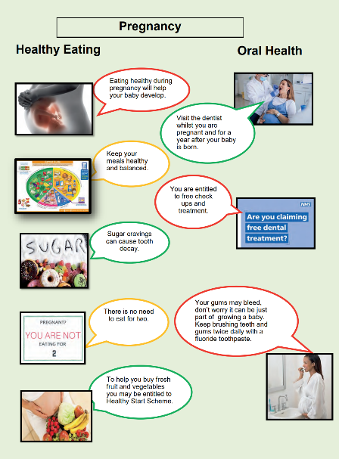
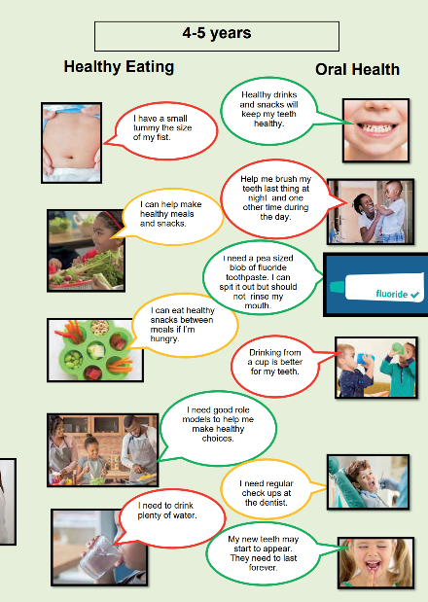
Manchester’s Healthy Families and Healthy Smiles leaflet was recently launched at this year’s baby week and features tips to support families with promoting good oral health and healthy eating habits from pregnancy up to school age.
If you would like a pdf version of the leaflet, please email louise.mcerlain@manchester.gov.uk
Our neighbourhood has the highest proportion of people living with type 1 diabetes of any other Manchester Neighbourhood. Within our communities with type 2 diabetes, we know our Asian and black African and black Caribbean are most effected and experience the highest inequalities.
NEIGHBOURHOOD NEWS……HEAR ALL ABOUT IT!
Health Development Coordinator Fiona Vincer shares news of diabetes and nutrition training being carried out in the Burnage, Didsbury and Chorlton Park neighbourhoods.

We started work with our Primary care network of local GPs to support people with their annual review. Patients with the highest proportion of non-attendance over 2 years were targeted and partnering with our PCN social prescribers and District nurses, patients from the practice with the highest inequalities were contacted, resulting in around 60% patients booked in for the review. Conversations revealed a variety of challenges around patients managing and feeling confident in their own conditions. We held focus groups in our communities and found out that many people didn’t understand the value of having a review, for others, it wasn’t always clear or possible to remember and interpret the volume of information they received, many experience digital exclusion and could not access or understand the array of supportive materials that were available, many have multi-generational issues within the family, and found it challenging to navigate the information they received.
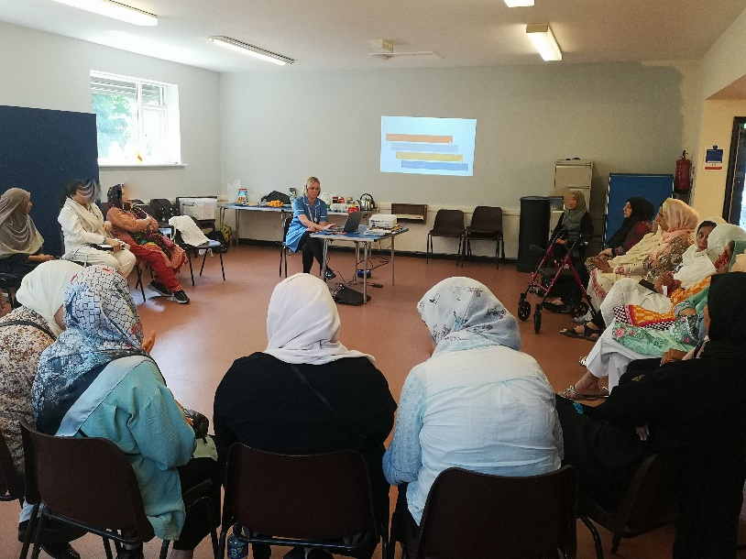
To address some of the issues raised and provide effective management of diabetes, we are starting peer support groups. We are seeking to deliver accessible education sessions looking at nutrition, healthy weight, physical exercises, and well-being, whilst focussing on different cultural needs and how this can impact on managing diabetes. The groups also aim to be an ongoing resource close to home where our PCN GPs and nurses can refer patients to learn about and get support around diabetes

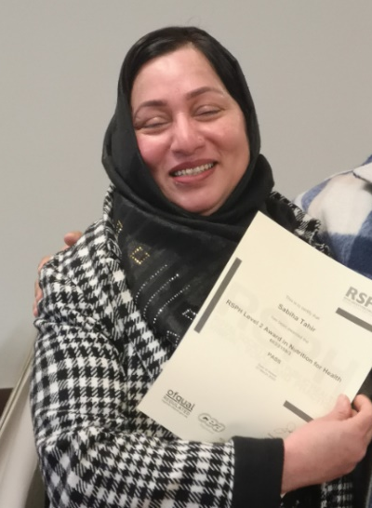
Level 2 award in Nutrition for Health has also been successfully delivered with 14 Asian women in Burnage, as part of ongoing work to reduce health inequalities for this community and build stronger relationships and trust. The outcomes sought for the women were to increase knowledge and information around food choices, health and cooking; create in a mutually supportive environment; explore challenges and solutions together, especially where English is not the first language.
Following completion of the course, women reported the changes they would make included, to fry less, grill and bake more, use less salt and oil, look at traffic lights on labels and guide to recommended intake, apply learning to their job with children and pass information to family and friends.
We continue to build work and relationships with this group of women, many of whom are also involved in an Asian’s women community health group.
The Manchester Food Board have launched the Manchester Food Strategy 2023-28 and includes recommendations for the public, private, voluntary and charity sectors to produce an innovative, sustainable and healthy food system.
The Healthy Weight team recently carried out a virtual educational session with more than 80 GP’s in Manchester to highlight the work the team deliver, and to further strengthen GP referrals to the service. The team works with nursery and reception aged children identified as severely obese and above by health professionals, and through the National Child Measurement Programme. During a 12-month programme, they provide 1-1 weight management support to the family including dietary, physical activity and behaviour change education and practical advice. The training delivered to GP’s was very well received and generated a lot of discussion on how children and families can be further supported.
If you would like more information about the Healthy Weight programme, please contact:
mft.healthyweightteam@nhs.net

To view the strategy in full visit: https://www.manchesterfoodboard.co.uk/our-purpose
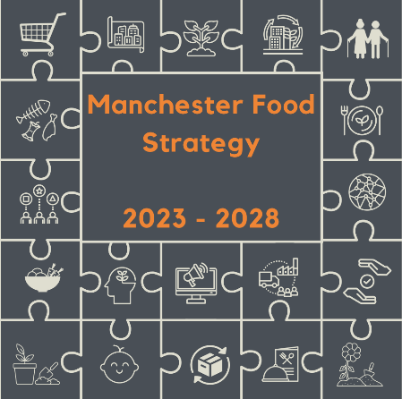

Better Health Childhood Obesity Campaign Resources
Helping and supporting families to make healthier choices by moving more and eating well. The website features marketing materials including the Children’s Healthier Eating Toolkit, Food Scanner App posters, NCMP posters and leaflets, social media toolkits and digital assets.

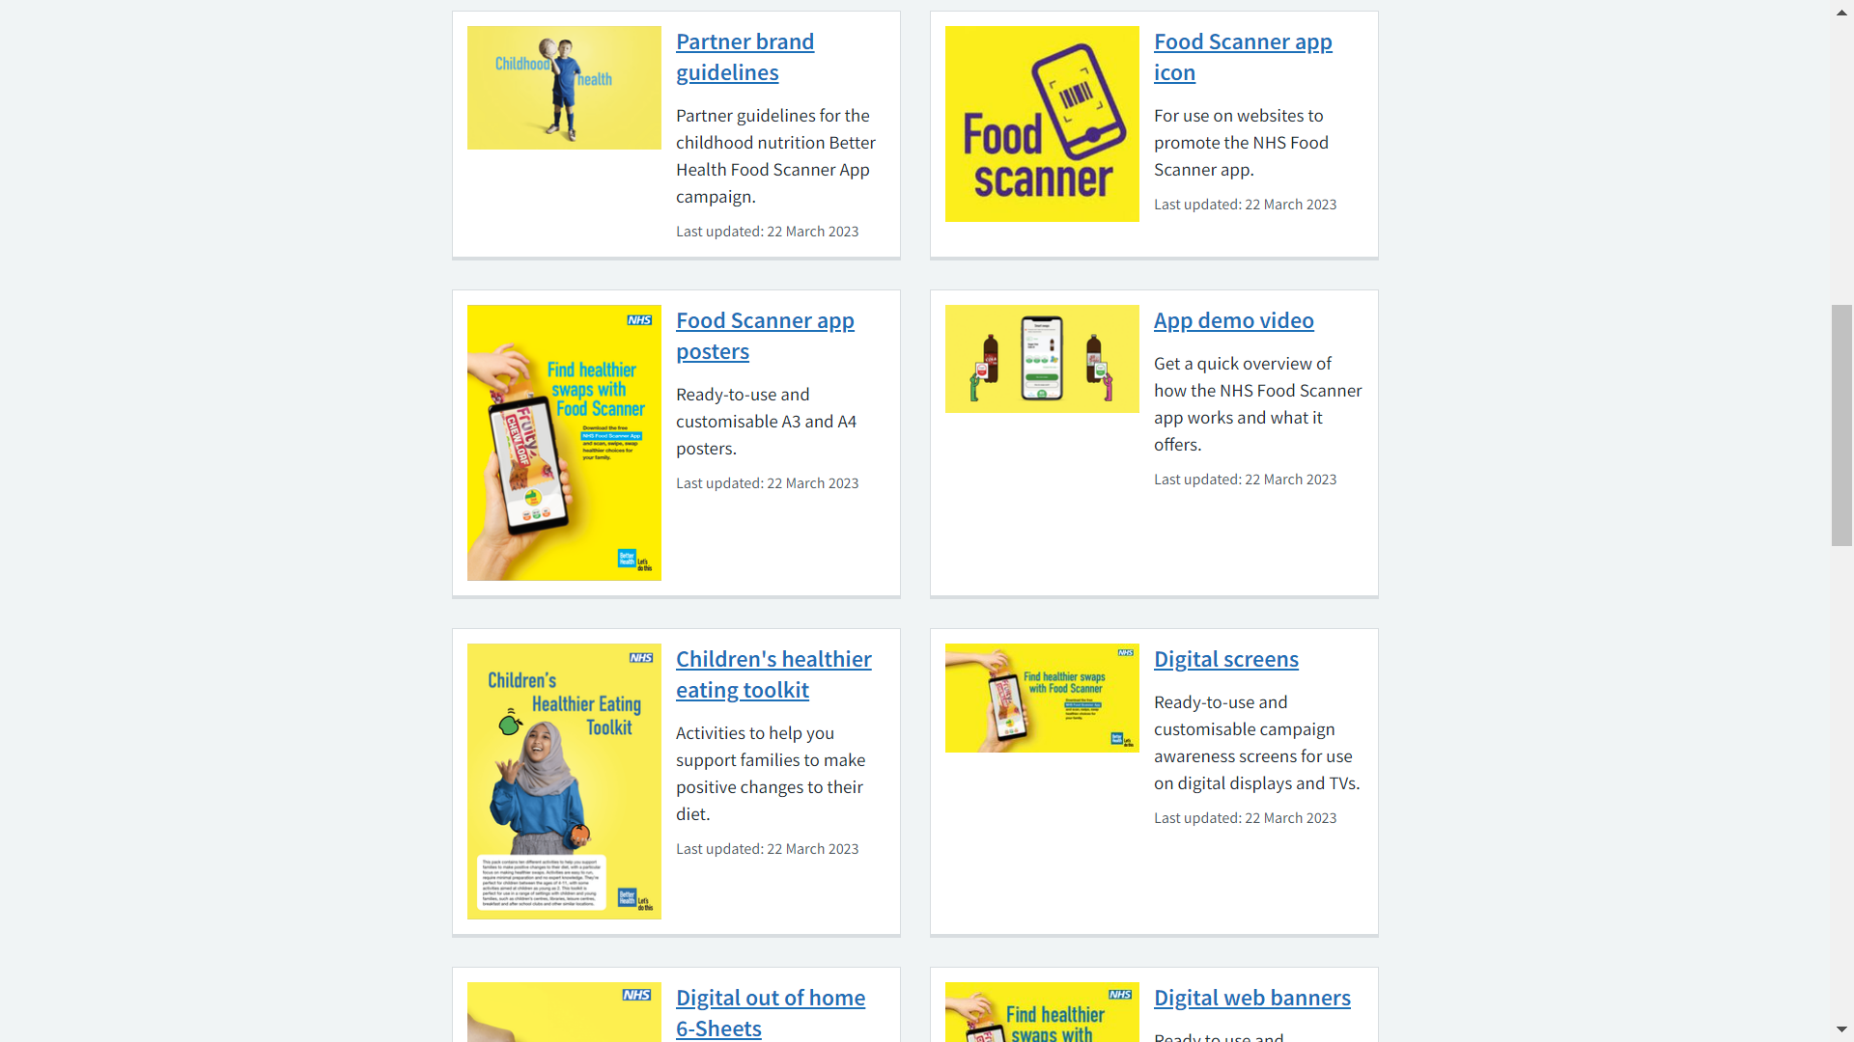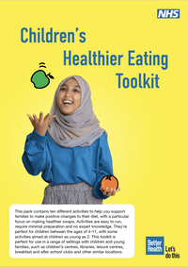

SWIM SUCCESS STORY!
Earlier this year GLL in partnership with MCC delivered a Targeted Swim Project, Leila Bedrum from GLL shares more information about the project.
Project Aims:
- Remove barriers for African and Caribbean participants
- Improve water confidence
- Improve health and wellbeing
- Learn to swim

Background:
Working with Patsy Williams, Neighbourhood Community Development Officer from Manchester City Council, she had lived experience of barriers to swimming for the African Caribbean community. Soul Cap caught her attention which led her to embark on consultation with the Manchester community during Black History Month to whether swimming, with the right support and conditions would be an activity to try. Partnering up with GLL and Soul Cap donating swim hats for participants 20 mainly women were offered 12 weeks of swimming lessons.
Programme:
Participants had several reasons to take part including, to be able to take children/ grandchildren swimming, learning to swim, to build confidence and let go of fears and to benefit their health and wellbeing. Swimmers looked forward to weekly sessions and found the support of others in the same position and the provision provided by swim Instructors made the sessions comfortable and enjoyable.
Feedback included:
“The social side was beneficial as I met other learners and formed a common bond with them. We would later stop and have a chat when we saw each other out in the community”.
“Swimming helped me to lose inches off my waistline and strengthen my core muscles”.
“Physical benefits were I have frozen shoulder and painful joints and arthritis and the exercise helped with the pain. It made me more flexible. Mentally it uplifted me and I felt better for going. Good chatting with other people , it was an evening out and I looked forward to it”
“Learning to swim means that I was able to enjoy the swimming pool on holiday and had more confidence going into the sea, and of course enjoy the swimming baths with my grandchildren. I will continue to access swimming in the coming summer months”.

A Targeted Swim Project Celebration took place at Moss Side Leisure Centre and following a short presentation networking took place over lunch which has created intention for ongoing work to engage more BAME residents through co-production by attending organisations.

Paul Schofield from Team Manchester has shared the information below about activities happening over the Summer:
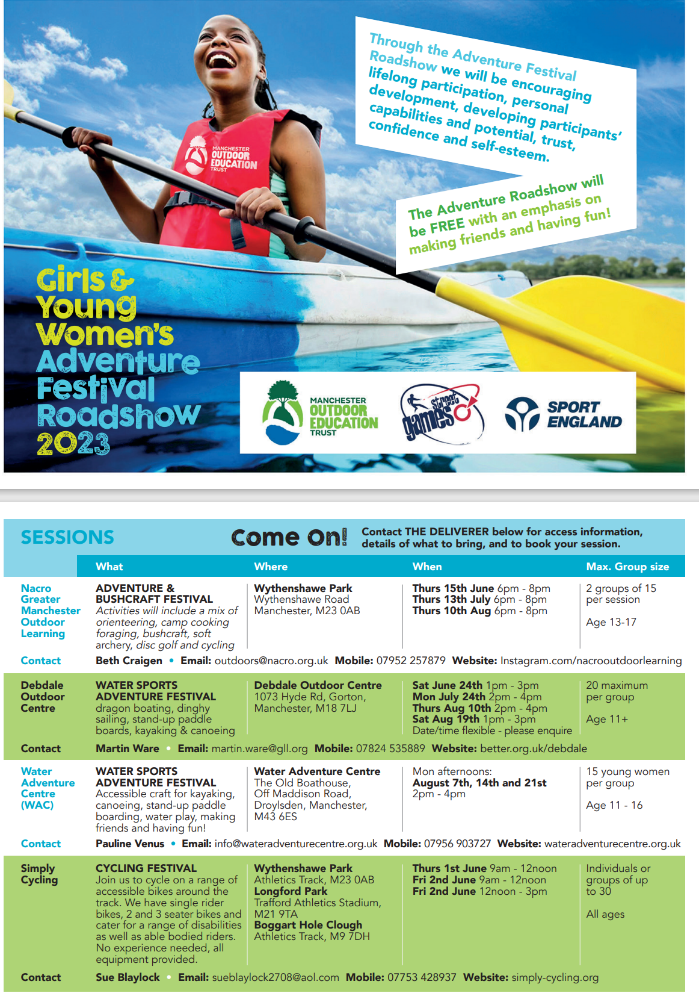

If you have a good news story to share in future newsletters or information about how your organisation supports Manchester residents with achieving a healthy weight, please email louise.mcerlain@manchester.gov.uk

