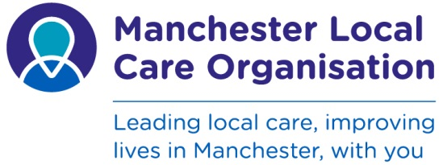

Children and Young People’s Services Referral Form
* Starred fields are mandatory. If any of these fields are not completed the form will be returned.
Please select the service you are referring to by marking “X” in one of the appropriate boxes below
Link to services – click to service name and press Ctrl |  |  |  | Physiotherapy Service |  | Occupational Therapy |  | Orthoptics | X
Paediatrics |  | Speech and Language Therapy |  | Children’s Community Nursing Team |  | Children's Continence Service |  | Children's Palliative Care Team (Star team)
Podiatry |  | Audiology |  | Children's Epilepsy Service |  | Children's Asthma Service |  | Other – please state
Please send referral form to service via post to Orthoptic Dept, Levenshulme Health Centre, Dunstable Street, M19 3BX or email to mft.orthoptic.referral@nhs.net NB this must be from an nhs.net email address.

Surname:*  Forename:*  Previous Surname:  Address:  Is copy appointment letter required: Yes / No  Please give details: | Date of Birth:  NHS Number:*  Gender:  Home Telephone:  Mobile Telephone:  E-mail Address:  Reminder required for appointments (if available):  Text: Yes/No

Language Spoken:* Religion:*
Interpreter Required:* Ethnicity:*
Preference for interpreter: Male Female Access Needs:
(Please delete as appropriate )

Early Help Assessment (EHA) Completed: yes/no *  Unique reference number (URN) :  Lead Professional:  Name:  Address:  Telephone:  Other Professionals Involved: | GP Name:  Practice Name:  Nursery / School Attended  CHRH

*Diagnosis / Reason for referral / treatment required: | Additional information (including test results or provide clinic letter as appropriate):

Referrer Name:  Designation:  Address:  Telephone: | Date of referral:  Have parents agreed to referral?

Office Use Only -
Date referral received …………………….....…............... Demographic details checked on child health system? Yes / No
Name……………………………………………….……….. Date……………………………………
Date of appointment………………………………………
CYPS ReferralForm.V2

