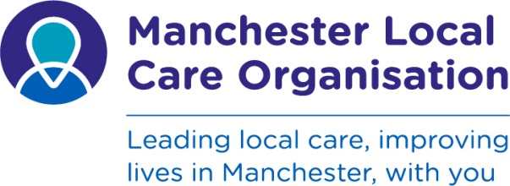

Safe and Healthy Baby Service
Referral Form

A family should be offered the opportunity for a meeting as part of the Early Help process when the case is NOT open to Children, Families & Social Care and they meet the criteria as set out overleaf: -

If you wish to discuss this referral, please contact us on 0161 861 2258

Staff/Agencies to complete the form below and send to - mft.shb@nhs.net

Mothers Full Name
and DOB
Address inc. postcode |  | Contact number of family
Contact details of referrer including telephone number and email |  | Date of referral /EDD
Consent obtained by: |  | Verbal/Written Consent

Name | Date of Birth | NHS Number (If Known) | Relationship
 |  |  | Mother
 |  |  | Unborn / Baby

Please list all Professionals below (if known) working with the family:-

Professionals Name |  |  | Designation | Contact Number | EMAIL
One of the following needed for Referral:
Concerns raised regarding parenting / bonding with baby
Previous history of unexplained infant death
Environmental or psychological barriers to following safer sleep advice
Late booking for antenatal care
Missed appointments / poor engagement
Mental health
Domestic abuse
Substance or alcohol misuse
Tobacco exposure
Homelessness or significant concerns re housing plus one other factor
Adverse childhood experiences that may impact parenting
Young parents
Other additional needs of parent or child

Reasons for Referral:

