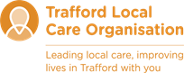
What is asthma?

Children’s Asthma Service
erlco.org

For more useful information
Children’s Asthma Nursing Service
Longsight Health Centre
Stockport Road
Longsight
Manchester M13 0RR
Telephone: 0161 248 1226

Asthma UK Adviceline:
Telephone: 0300 222 5800
Website: www.asthma.org.uk

Allergy UK
Telephone: 0132 261 9898
Website: www.allergyuk.org

Who provides this service?
The Children’s Asthma Service is provided by Manchester Local Care Organisation.
MLCO is the organisation that provides NHS community health care and adult social care in the city. It is a partnership organisation between the NHS and Manchester City Council.
You can find out more about MLCO at www.manchesterlco.org

Other languages
This leaflet can be produced in other languages on request. We can also provide the information in other formats including Braille, large print and audio CD. Please contact us if you require help.

Compliments and complaints
The Patient Advice and Liaison Service (PALS) is a confidential NHS service that provides help, advice and information for patients, families and carers. We welcome all your feedback about the service. Contact PALS at:

- Email: pals@mft.nhs.uk
- Telephone: 0161 276 8686

Please visit our web pages at www.mft.nhs.uk/community/childrens-community-services-citywide/ to find out more about our services.

Leaflet produced by Manchester Local Care Organisation Asthma service- January 2022.
Review date - January 2024.

What is asthma?
Asthma is a common condition that affects the airways – the small tubes that carry air in and out of the lungs. This makes it harder to breath.

The muscle around the airway tightens, making it narrower. The lining of the airway becomes red & sore. It swells and produces sticky mucus.

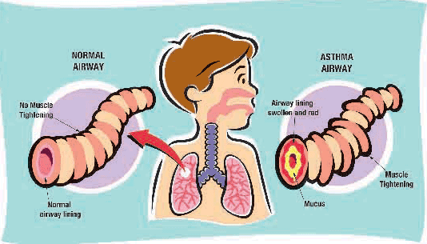
If you have asthma you may:

- Cough - particularly at night and after exercise
- Wheeze – a whistling noise
- Get short of breath
- Have a tight feeling in your chest.

Everyone’s asthma is different. You may have some or all of these symptoms from time to time. Some people experience symptoms when they get a cold, others are worse at night or first thing in the morning. But most importantly you shouldn’t have to put up with symptoms!

Asthma treatments should help you get full control of the condition. There are two main kinds of treatments relievers and preventers.

- Relievers - help to open up the airways when they tighten up, relieving the symptoms

- Preventers - help to control the swelling in the airways and reduce the chance of symptoms. Preventer treatments need to be taken everyday even when you are well.

Most asthma treatments are inhaled (breathed in), as this is the most effective way of taking them. Even babies can inhale asthma treatments through a spacer, rather than use syrups.

Diagnosing asthma
Diagnosing asthma can be difficult, especially in young children because:

- Lots of children will wheeze at some point during their first five years, especially if they have a cold
- It is not easy to measure how well the lungs are working in children.

However looking at a pattern of the symptoms over time, will help your nurse or doctor determine whether or not your child has asthma and you may be asked to keep a diary.

Asthma Facts
- Asthma is very common, 1 in 10 children in the UK have it
- Asthma can start at any age
- The exact cause of asthma is not known, but the tendency to develop allergies, including asthma, often runs in families
- Asthma is related to other allergic conditions, such as eczema and hayfever
- Passive smoking increases the likelihood of a child developing asthma.

