Children’s Asthma Service

Information leaflet
erlco.org

Who do I contact?
Children’s Asthma Nursing Service
Longsight Health Centre
Stockport Road
Longsight
Manchester M13 0RR
Telephone: 0161 529 6638
Our service opening times are Monday to Friday 8am to 5pm excluding Bank Holidays.
The nurses are not always in the office to take your calls, alternatively, you can leave a non-urgent message on the answer phone.

Who provides this service?
This service is provided by Manchester Local Care Organisation.
MLCO is the organisation that provides NHS community health care and adult social care in the city. It is a partnership organisation between the NHS and Manchester City Council.
You can find out more about MLCO at www.manchesterlco.org .org

Other languages
This leaflet can be produced in other languages on request. We can also provide the information in other formats including Braille, large print, and audio CD. Please contact us if you require help.

Compliments and complaints
The Patient Advice and Liaison Service (PALS) is a confidential NHS service that provides help, advice and information for patients, families, and carers. We welcome all your feedback about the service. Contact PALS at:

- Email: pals@mft.nhs.uk
- Telephone: 0161 276 8686

Please visit our web pages at www.mft.nhs.uk/community/childrens-community-services-citywide/ to find out more about our services.

Leaflet produced by Manchester Local Care Organisation Asthma service– January 2022.
Review date – January 2026.



Who we are
We are a team of asthma nurse specialists, providing management, education and support to children and their families with asthma, cough, wheeze and/or shortness of breath.
Referrals to the service can be arranged through your GP, practice nurse, consultant, school nurse or other health professional.
If you feel you need to speak with a nurse regarding your child being referred to the service, please don’t hesitate to contact us.

What areas do we cover?
North Manchester
South Manchester
Central Manchester
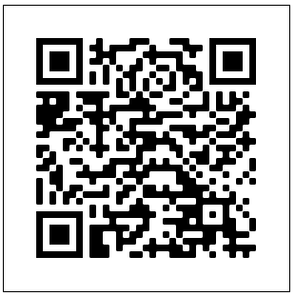
 Follow us on facebook
Instageam/ Twitter – ccasthma_manc

Who is the service for?
The service is for children age 3-16 years, or up to 18 years for children with complex needs whom have a Manchester Address.

What can the service offer?
- Partnership working with the child, young person, and family - empowering them to be able to manage their condition
- Nurse- Led clinics in community setting
- Provide education, advice, treatments, and support
- Partnership working with other health professional’s pre-school and schools
- Shared care with involved health professionals.

What will happen at your appointment?
- Your appointment may last up to 45 minutes.
- You will need to bring any medication/inhalers your child may be taking.
- At the appointment, the nurse will assess your child/young person and give you information to support your needs so that you and your child/young person feel more confident about managing their asthma/wheeze safely and effectively. This may mean more than one visit.
- Once your child is better/you feel happy about looking after their asthma/wheeze and have an action plan to follow, they will be referred to their GP or practice nurse.



