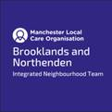
Wythenshawe (Brooklands) & Northenden Neighbourhood Partnership Update

Happy New Year everyone, I hope this email finds you well and rested after a hard 2020
(Started writing this email a few weeks ago – still going to wish everyone a happy new year!)

Neighbourhood Update
Please find attached the latest update from the team, feel free to share, host on your website and/or feedback.
As always historical updates hosted on the MLCO neighbourhood page https://www.manchesterlco.org/wythenshawe-brooklands-and-northenden

Neighbourhood Partnership Meeting
Thanks to all that attended the last Neighbourhood Partnership Meeting which focused on addressing inequality in Wythenshawe (Brooklands) & Northenden. It was really well attended, in fact nearly blew the agenda timings out of the window with the introductions!

The notes are attached and although I thought I was really organised and did well for remembering to record the session, for the life of me when it came to writing it up I couldn’t find the recording (story of my life)!
The discussion was rich and its important to let you know how the discussions at that meeting have influenced plans and work

A lot of the points raised were used to develop and get a up to date picture of the needs of people living and working in Brooklands and Northenden.
- The discussions and data presented was fed into work our GP practices are doing to support inclusion within their delivery models
- The discussion is shaping the work that we collaborate on over the next year and will allow us to prioritise the issues that affecting our residents most.
“Its hard to plan how and what we can do especially with the changing in rules practically on a daily basis, we need to continue these networks and connecting to work smarter and keep the momentum. Sharing funding opportunities and partnerships is important “

Neighbourhood Flu Campaign

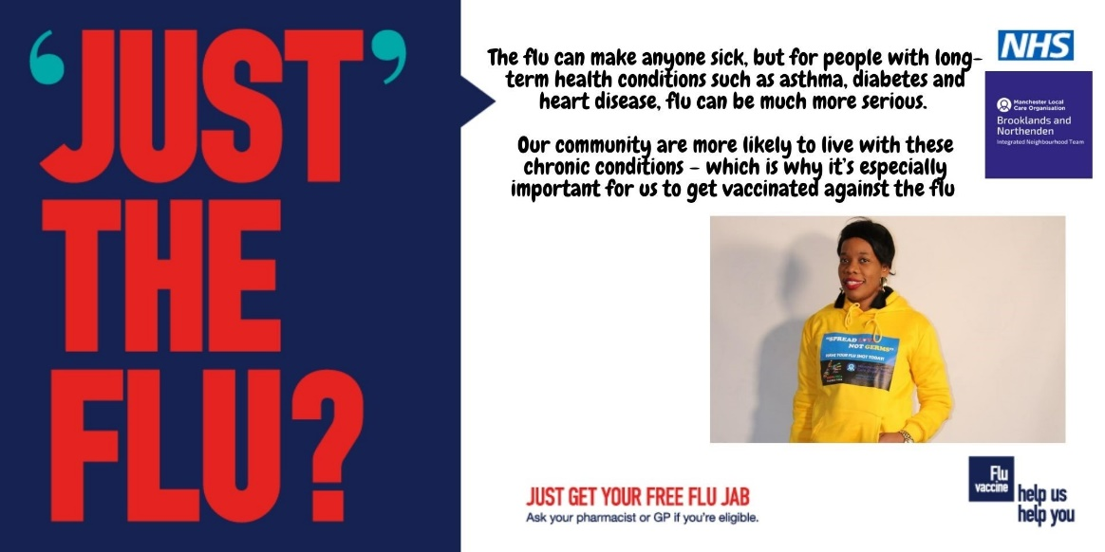
Thank-you for all your hard work in promoting and encouraging people to have their flu vaccination. You can still have your Flu vaccination via your local pharmacy

We have worked together on a lot of this work, running engagement sessions with people who don’t tend to have the vaccination, radio shows/soundbites & visiting and working with Local primary School. The flu season continues and we are encouraging those people who have not had their jab to consider having it, especially with all we are hearing about the hospitals at the moment. It’s crucial that we do our best to avoid winter admissions

I attach an email from Gilly and Paul which celebrates the improvement in uptake this year – Massive thanks for contributing to this.

Covid Vaccination Clinics
Finally, you will have seen that we have been delivering the Covid vaccination at the lifestyle Centre over the last few weeks. It feels great that we have started to vaccinate people who are most at risk. Thanks to all that responded to the call out for volunteer help a few weeks ago.

The rapid rollout of a vaccine against Covid-19 represents the best and fastest way of life returning to normal. Vaccines are safe and effective at limiting severe illness. Please urge anyone contacted by their GP in regard to getting a vaccination to stick to their appointment.

As more and more vaccination centres are stood up there is a need for help for the local community. If you can offer your time to support the marshalling of the centres, please do consider signing up.
https://manchestercommunitycentral.org/vaccination

I also attach an email I received over the weekend from MACC which provides more details regarding vaccinations for VCFSE frontline workers.

Please do keep in touch- wishing you all the best
Rachel
______________________

Updates

Neighbourhood Health & Wellbeing –

Thinking differently, a partnership approach
Health Foundation – What makes us Healthy
What makes us healthy? - YouTube
Covid-19 | Volunteering at Vaccination centres  https://manchestercommunitycentral.org/vaccination  Community Comms Tool https://secure.manchester.gov.uk/info/500362/covid-19/7985/translated_covid-19_assets/2  The Manchester Community Support Hub – Still there  The hub can help with access to food, medication deliveries, fuel top-ups, helping to get access to online services, and combat loneliness.  If you need help, call 0800 234 6123 9am - 5pm Monday to Friday.  Or text 07860 0202 876 for a response the next working day.
Care Navigation and Social Prescribing | If you are concerned that someone you know might be at risk and in need of some practical support then you can contact:  Care Navigator Service (Lucy is our Care Navigator)  Referrals are made via mft.carenavigators@nhs.net or phone, 0300 303 9650  Be Well (Leon, Abby, Sam & Jayne)  Referrals now via any organisation: bewell.mcr@nhs.net or 0161 470 7120
Nuffield Health and MFT  free 12-week rehabilitation programme | Nuffield Health is launching a free 12-week programme in partnership with Manchester University NHS Foundation Trust  Nuffield Health, the UK’s largest healthcare charity, is launching a specialist 12-week rehabilitation programme in Manchester to support patients in their recovery after they have received medical treatment for COVID-19.  The programme blends together physical therapy and mental health support and will be run in partnership with Manchester University NHS Foundation Trust, as well as other trusts across the UK, before being developed into a national programme.  https://mft.nhs.uk/2020/11/09/covid-19-patients-in-manchester-to-benefit-from-specialist-recovery-programme/

Neighbourhood communications
Regular Neighbourhood radio slot on Wythenshawe FM | Would you like to get your key messages out to a wider audience?  Rachel.harding9@nhs.net
Neighbourhood Partnership emails | Continue to forward Rachel neighbourhood information to share
Neighbourhood Facebook and twitter pages | Twitter: @BrookNorthINT /@HealthySouthMCR  Facebook: https://www.facebook.com/BrookNorthINT/

Basic Needs
Manchester community Response Hub | If you or someone you know requires help with food, medicine, household bills or are feeling isolated then call 0800 234 6123 or email: COVIDSupport@manchester.gov.uk
Energyworks – LEAP project | Energy and money saving service  Please refer in to the LEAP project by referring directly through the website https://applyforleap.org.uk/apply/ or by ringing 0800 060 7567 and one of the Energyworks Green Doctors will help.  If you have a question regarding saving energy or how to support your customers during this pandemic please contact our Green Doctors directly on 0800 090 3638 or at energyworks@groundwork.org.uk  The support and advice we offer includes, but is not limited to;  - Checking energy bills and offering an independent switching service  - Dealing with the energy company on behalf of the customer around debts and discrepancies of their bills  - Behavioural advice to reduce energy usage in the home while staying warm  - The fitting of free small energy saving measures – LED energy efficiency lightbulbs, radiator foils, draught proofing, chimney balloons etc…  - Referrals to external services (with customer permission) who are able to offer further addition support  - Funding for larger measures – free replacement broken boilers, free 1st time central heating systems, loft and cavity wall insulation (subject to eligibility)  - Green Homes Grant advice  - Possible reduction/capping of water rates  - Other grant funding  - Metering issues  - White goods replacement service  - Free CO monitors
Citizen Advice - Video Drop ins | https://www.citizensadvicemanchester.org.uk/video-advice

Long term conditions
Managing living with a long Term Condition | Are you living with a long-term physical condition?  Living with a long-term condition isn’t plain sailing and we don’t always get the support we need when things get tough. This course is for anyone living with a long-term physical condition and who wants to find ways of managing and improving their psychological wellbeing. The course aims to help lift your mood and will teach you a range of tools and technique to manage stress and life’s challenges. The course takes place live on zoom over 6 sessions of two hours each.  The next course starts on February 10th, and session times are 11 – 1pm. Register online here: https://bit.ly/3mQkGKd  Contact Ruth.Rosselson@manchestermind.org if you would like to have a chat about the course before registering.

Volunteering and Mutual Aid

Start Well, Develop Well

Healthy Lifestyles

Mental Health and Wellbeing
Mindfulness and Relaxation for menopause | FREE 8 week course, focusing on using mindfulness and relaxation techniques to help manage the psychological  impacts of this life transition  https://data.manchestermind.org/civicrm/event/info?reset=1&id=166  Ruth.Rosselson@manchestermind.org (0161) 769 5732 / 07527 127 786

Age Friendly Neighbourhood

Digital Support
Endless 5G ready data, calls and text for job Seekers | The mobile provider VOXI (Vodafone) have released a package for Jobseekers which allows them Unlimited Minutes, Unlimited Messages and Unlimited 5G Data for £10 per month. There’s no credit check, no contract to sign and will give them this deal for 6 months. They just need to upload evidence that they are receiving benefits. The deal is available until 31 January 2021 and can be sought directly through their website https://www.voxi.co.uk/for-now.
Manchester Adult Education Service - Skill up sessions | MAES / Manchester Adult Education Service are offering Skill Up sessions where residents can come for between 1-6 sessions to learn anything they need re digital. Sessions are face-to-face across venues in Manchester (and hope to stay open even after this Thursday restrictions).  https://manadulted.org.uk/courses/digital/  People will need to fill out on short online form. It used to be a drop-in but due to Covid, learners do need to book in advance and no obligation to attend all 6 sessions.

Carers
Emergency Fund opens for Manchester’s unpaid carers | Carers can receive advice about accessing this financial support by ringing the Manchester Carers Contact Point: Monday to Friday from 10am to 4pm on 0161 543 8000 or their Young Carers Coordinator.  Alternatively, carers can email contactpoint@carersmanchester.org.uk or visit www.manchester.gov.uk/carers and click on the Carers Emergency Fund tab or visit www.carersmanchester.org.uk
Carers Manchester Contact Point: | a dedicated helpline for carers to access support and guidance. The team includes advice workers who can provide support in other languages:  0161 543 8000  Monday – Friday  10am – 4pm  Except Bank Holidays  contactpoint@carersmanchester.org.uk

Funding and Financial Support
Grants to support BAME-led organisations affected by Covid-19 | Grants of £1000-£5000 are available to GM BAME-led VCSE organisations, with an income of £50,000 or less, to respond to the needs of their communities during the Covid-19 pandemic.  Applications for this round close on Friday 26th February 2021 at 4pm.  These grants are funded by Comic Relief and the National Emergency Fund in response to Covid-19.  https://www.gmcvo.org.uk/emergency-grants-gm-bame-communities
WCHG – Community Development Grants | Next Community Development Grants Panel scheduled for 28th January. If you have any ideas for community development grants, particularly if they can support your organisation with your COVID 19 response then we’ welcome your application  https://www.wchg.org.uk/community-development-grants/
Manchester City Council Covid-19 Impact Fund | Manchester City Council is launching a Covid-19 Impact Fund on Wednesday January 6th 2021. £300,000 will be available for voluntary sector activity to support mental health and wellbeing and reduce social isolation in Manchester.  Offer from Caritas Shrewsbury to hold funds for unconstituted groups Ben.gilchrist@caritasshrewsbury.org.uk  To apply:  http://surveys.manchester.gov.uk/s/CIFMentalHealth/  quesiotns:  omfunds@manchester.gov.uk  We are particularly interested in support for the following groups:  • BAME communities  • Disabled people  • LGBTQ+ communities  • North Manchester residents  • Older People  Grants available:  • up to £10,000 for organisations applying on their own  • up to £30,000 for organisations applying in partnership  Deadlines:  We want to support residents as early as possible in the New Year so there will be three deadlines for applications. These are: Monday 18th January, Monday 8th February, Monday 1st March.  Unconstituted groups can partner with a constituted group – see offer above

VCSE advice, support and guidance

