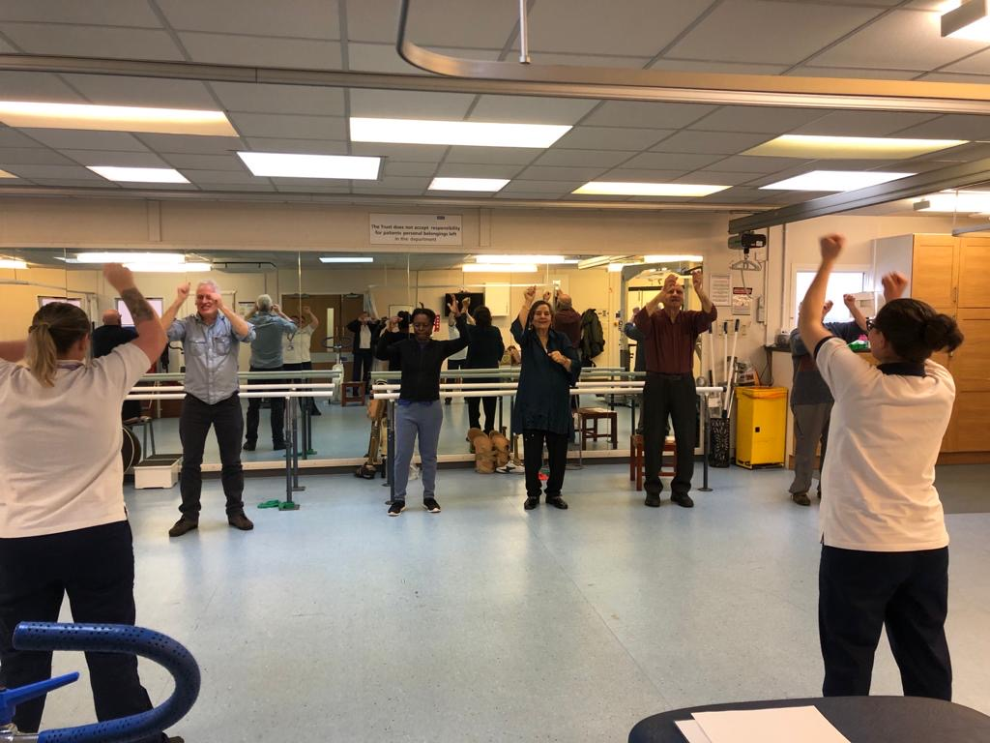

Contact

Community Neuro & Stroke Team

Alexandra Park Health Centre

2 Whitswood Close

Manchester

M16 7AP

Tel. 0161 209 9965

ManchesterLCO.org

**Your Therapists:**

……………………………….

……………………………….

……………………………….

……………………………….

**Telephone**

0161 209 9965

If your call isn’t answered please leave an answerphone message and we will return your call as soon as possible.

Community Neuro & Stroke Team

For patients with a Central Manchester GP

**What if I am unable to attend my appointment?**

If you are unable to attend your appointment, please notify the department as soon as possible on: **Tel: 0161 209 9965** so that we may offer the appointment to another patient.

We will do our utmost to give you the appointment at a time that is convenient to you, however the demand for appointments may affect this. We try not to cancel appointments once made, but sometimes this is unavoidable.

It is the Trust’s policy that if you do not attend an appointment without informing us, you will be discharged from the service. Repeatedly cancelling appointments or if you do not contact us to rearrange missed appointments will also result in being discharged from the service. Rehabilitation is a course of treatments and missing appointments detracts from its effectiveness.

**First Appointment**

The first appointment will take place either at home or in our therapy gym. Your appointment letter will state where the appointment will take place.

The first appointment will usually be with two members of staff and consist of an assessment of your condition. This will involve some questions regarding the nature of your problem and past medical history followed by a brief physical assessment if required and if time allows. We may need to continue some aspects of our assessments at follow up appointments.

Following your assessment, your therapist will discuss with you what your goals are, and establish a plan to achieve this. Rehabilitation is seen as a partnership between the therapists and a patient. Co-operation with advice and treatment regimens is essential for its effectiveness, this often includes doing exercises yourself at home as directed by your therapist.

Any information that you give to the therapist is confidential but may be disclosed to other professionals when of benefit to you as a patient. Any letters are also sent to your GP who co-ordinates your healthcare requirements unless you specify otherwise.

# **About our team**

# The team includes Physiotherapists, Occupational Therapists, Speech & Language Therapists and Rehabilitation Assistants. We work closely to treat patients in the most appropriate setting. This could include:

# Therapy Gym in Therapy Services Unit 2, Manchester Royal Infirmary.

# Patient’s home or residence.

# Group exercise classes.

# Community Environment

**What do we offer?**

We aim to enable our patients to achieve their potential by providing specialist multidisciplinary neurological rehabilitation.

The aim of our treatment is:

* To achieve patient centred goals.
* To provide individualised treatment specific to your needs.
* To allow you to enjoy the best quality of life.
* To be able to manage your condition in the long term (known as self-management)